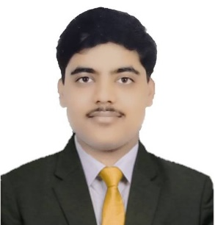

SANSKAR AGRAWAL

Address- FLAT NO.617, SILVER ESTATES,

GWALIOR (M.P)

Phone: +91 7021564245

Email: sanskaragrawal3401@gmail.com

[www.linkedin.com/in/sanskar-agrawal697b85216](http://www.linkedin.com/in/sanskar-agrawal-697b85216)

# CARRER OBJECTIVE

To work as a software engineer applying my knowledge in the field of designing, testing and maintenance to cater to the specific needs of the people. I wish to work in a team of motivated individuals who wish to work towards the advancement of the company and its goals.

TECHNICAL SKILLS

C++ | JAVA | PYTHON | HTML | CSS | JAVASCRIPT|PYTHON

# INTERPERSONAL SKILLS

Team Player| Management and Organization| Quick learner|

Time Management

# ACTIVITIES AND INTERESTS

•Travelling •Tennis •Music

• Gardening

# PERSONAL DETAILS

Mother Name: Sarita Agrawal

Father Name: L.D. Agrawal

D.O.B: 3rd April,2001

# EDUCATION

## BACHELOR IN COMPUTER SCIENCE ENGINEERING

CHANDIGARH UNIVERSITY, GHARUAN

SESSION:2020-PRESENT

## INTERMEDIATE (CBSE)

O.P. JINDAL SCHOOL, MUMBAI

SESSION:2019-2020 |SCORE: 6.8 CGPA

## MATRICULATION (CBSE)

O.P. JINDAL SCHOOL, MUMBAI

SESSION:2017-2018|SCORE: 8.8 CGPA

# PROJECTS

**ARTIFICIAL INTELLIGENCE BASED WINDOWS ASSISTANT** February 2022 - May 2022

* Designed a windows assistant using Python.
* A windows assistant made with the help artificial intelligence like Cortana, Siri using Python and its libraries.

**FULLY FUNCTIONAL HOTEL WEBSITE**

June 2021 - July 2021

* Designed a fully functional hotel website using web development.
* A fully functional hotel website for bookings was made using HTML, CSS & JAVASCRIPT for frontend and MYSQL XAMPP were used for backend.

**SMART AGRICULTURE SYSTEM**

February 2021 - May 2021

* Designed a smart agriculture system using Internet of things (IOT).
* Performed an analysis on light, humidity, soil moisture and provide accurate and vital information for monitoring the crop field with the help of sensors.

# CERTIFICATIONS

* Frontend Web Development Bootcamp Course from Coursera
* Computer Network Course from Coursera
* Ethical Hacking Course from Internshala
* Software Testing Course from NPTEL

# EXTRA CURRICULAR ACHIEVEMENTS

• Inter School Swimming Champion In 2017